Thirteenth task of my ingternship
- Customer can order products from the frontend.
- Orders should be displayed in the Admin Panel.
- A new email should be generated and sent to both the customer and the admin.
- Add PayPal Sandbox for testing purposes.

Step 1: Create orders Table
In phpMyAdmin, run:
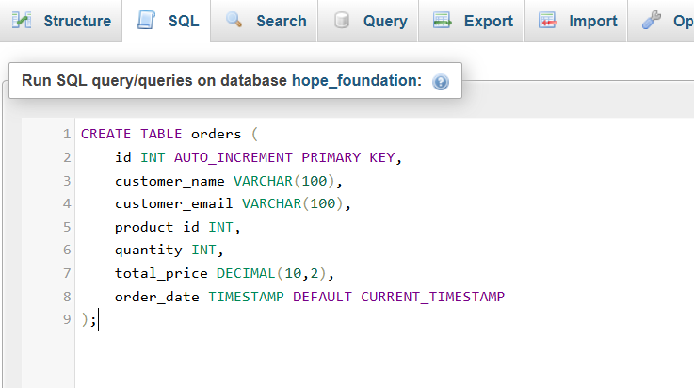
STEP 2: Create checkout.php
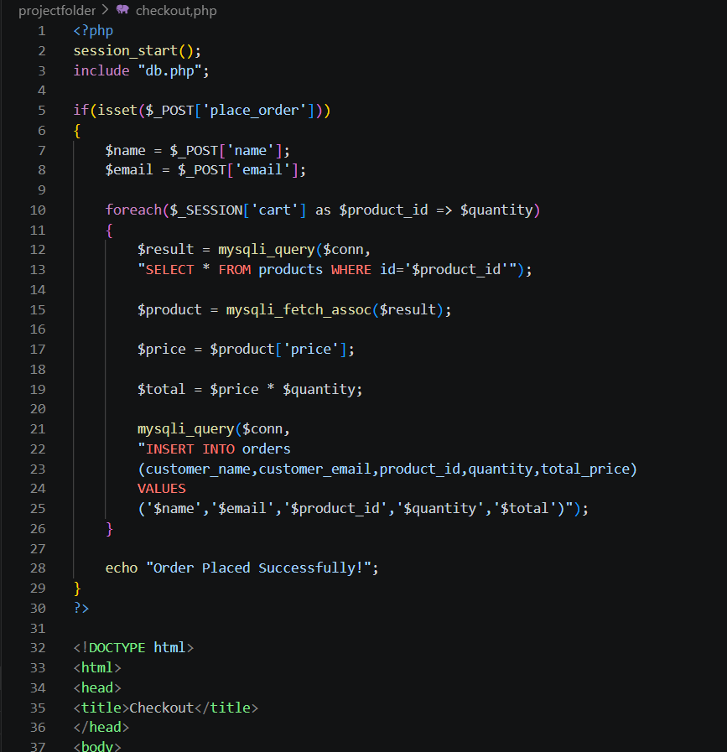
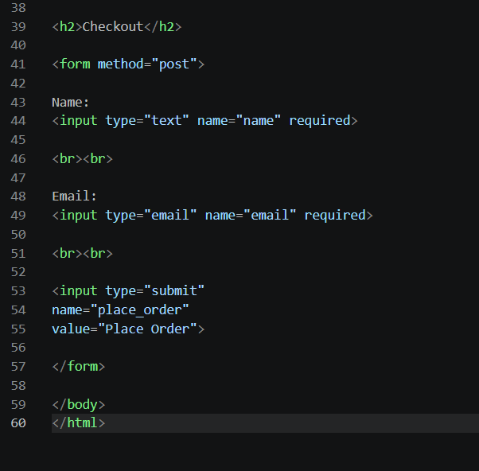
STEP 3: Modify your existing cart.php
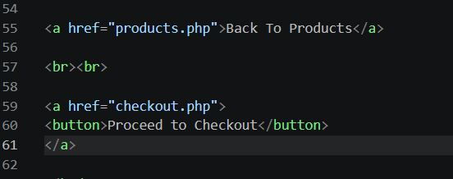
STEP 4: Create Admin Order List
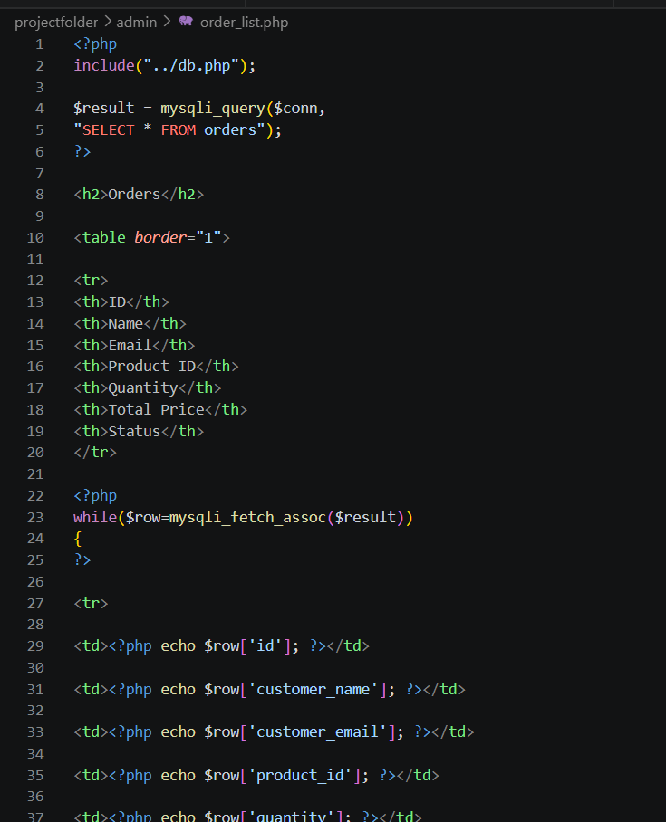
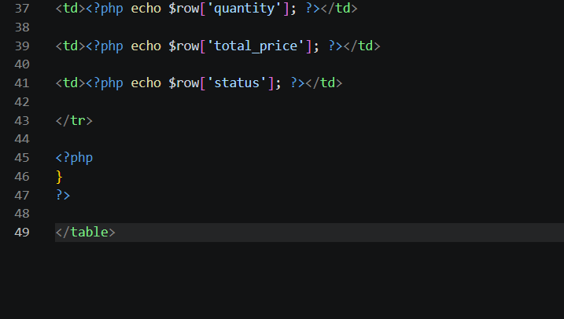
STEP 5: Test
http://localhost/projectfolder/products.php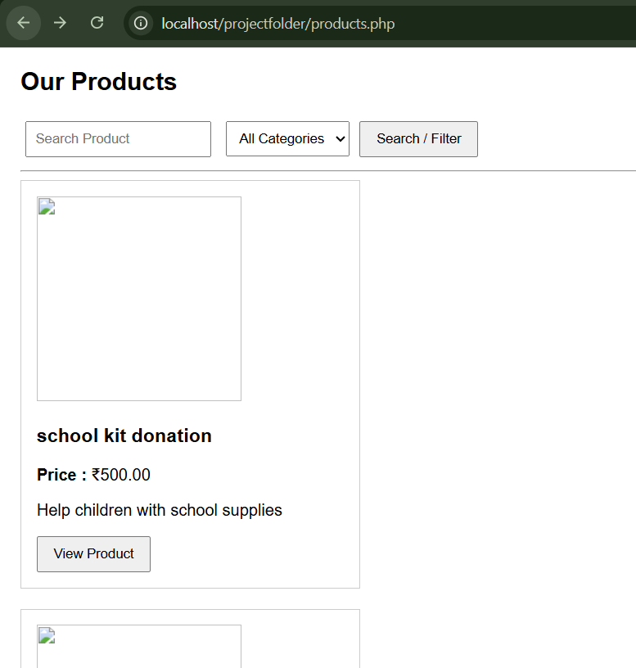
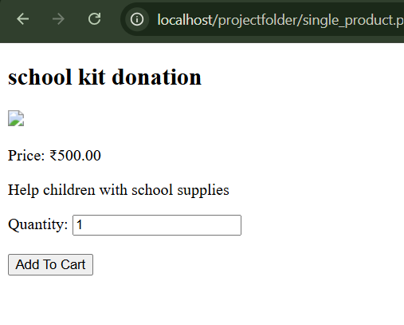
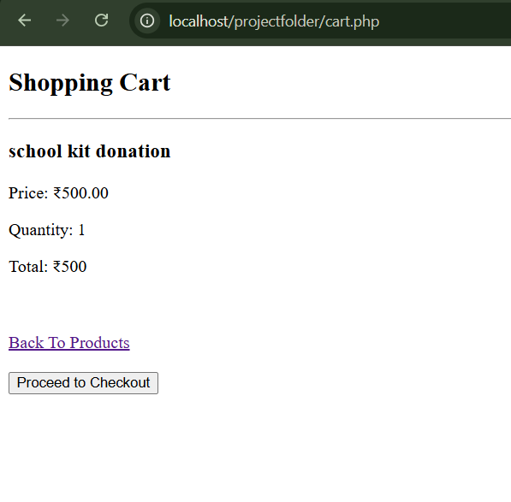
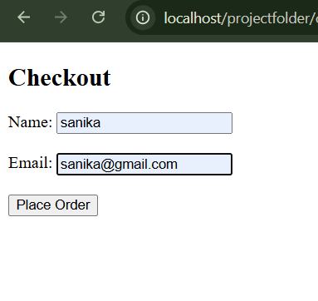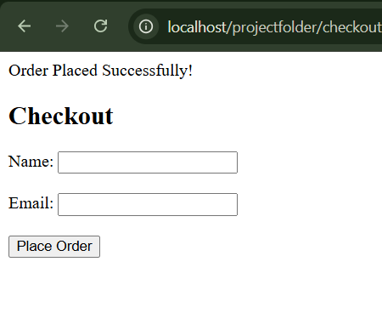
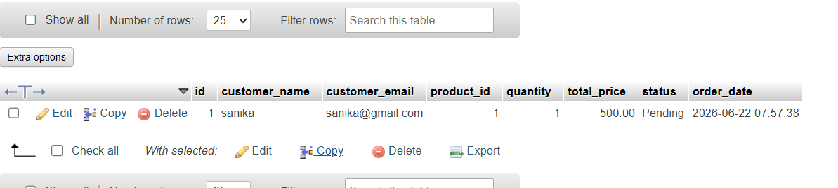
Step 6: Download PHPMailer
Download ZIP from:
https://github.com/PHPMailer/PHPMailer
Extract it.
Copy the src folder into:
projectfolder/
│
├── PHPMailer/
│ └── src/
STEP 7: Generate Gmail App Password
Go to:
Google Account
↓
Security
↓
2-Step Verification (Enable it)
↓
App Passwords
↓
Select App → Mail
↓
Generate
Google will give you a 16-character password like:
abcd efgh ijkl mnop
STEP 8: Create send_mail.php
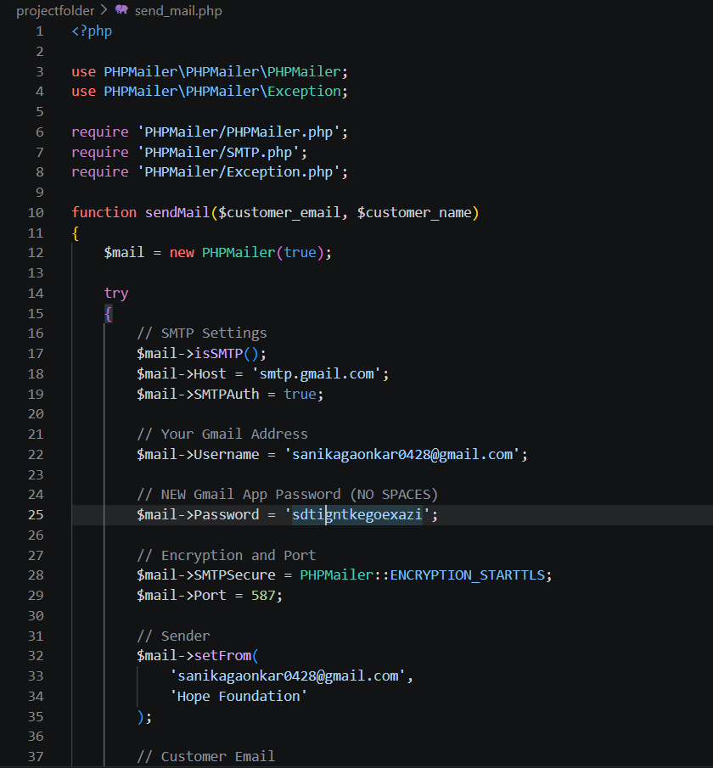
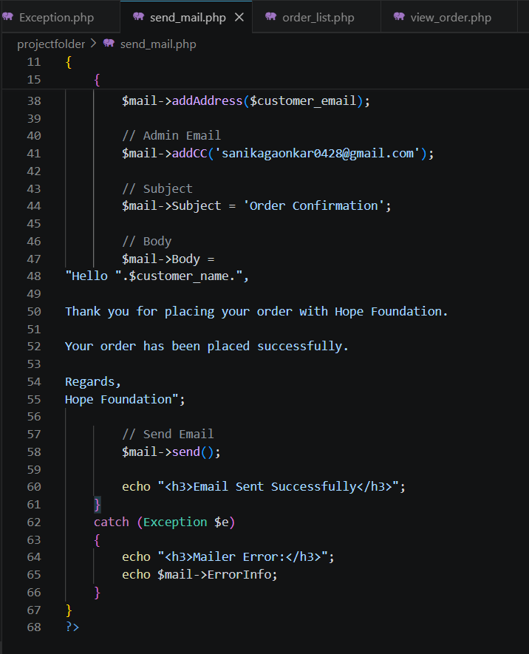
STEP 9: Create view_order.php
Inside the admin folder create:
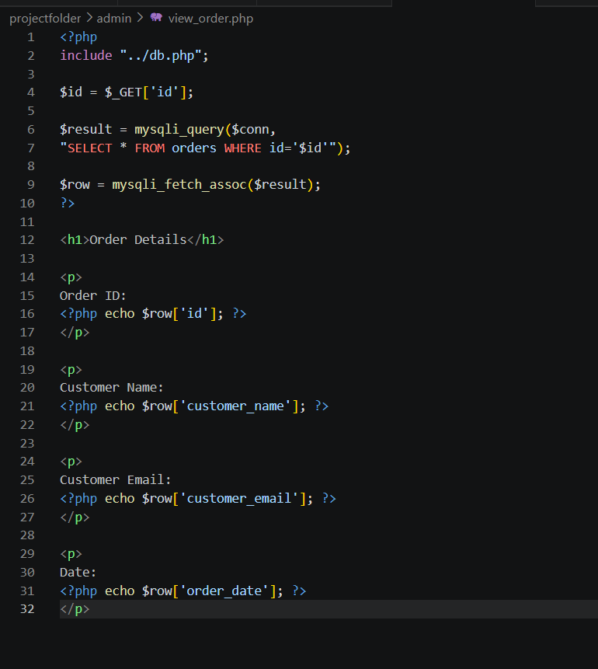
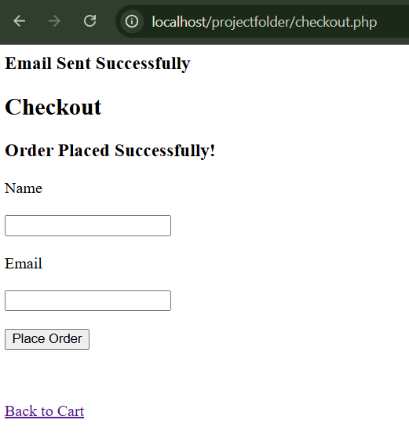
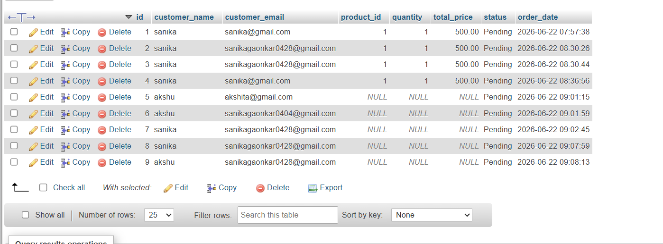
Next: PayPal Sandbox Integration (Testing Payment)
Step 1: Create PayPal Developer Account
Go to:
🔗 https://developer.paypal.com/
Login with your PayPal account.
Step 2: Create Sandbox Accounts
- Dashboard → Testing Tools
- Click Sandbox Accounts
- You'll see:
- Business Account (merchant)
- Personal Account (buyer)

Step 3: Get Client ID
Go to:
Apps & Credentials → Sandbox
Create an app (if none exists).
Copy the Client ID.
Step 4: Create paypal.php
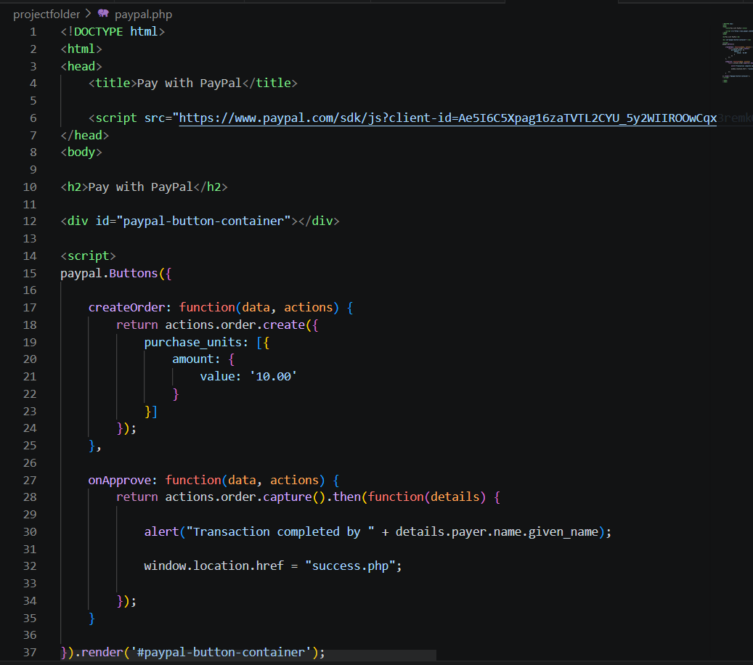
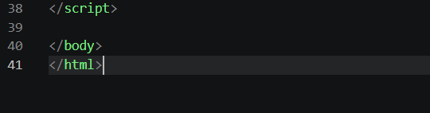
Noe create success.php:
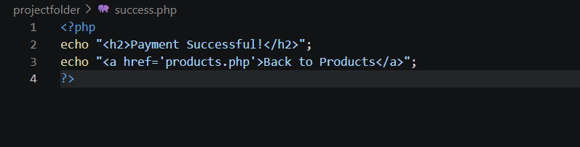
Test:
http://localhost/projectfolder/paypal.php
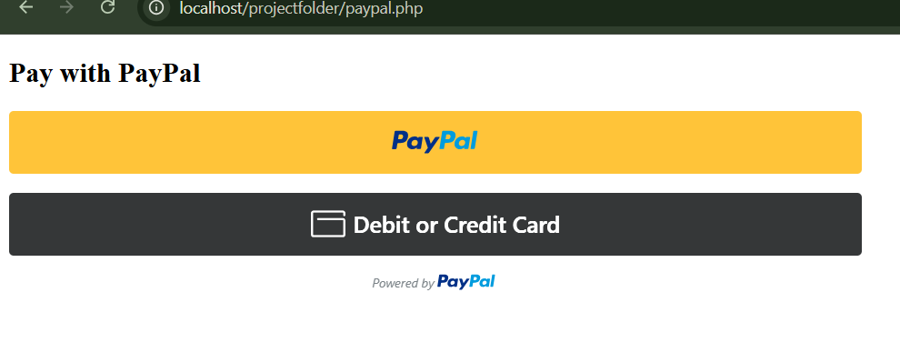
Step5: update success.php
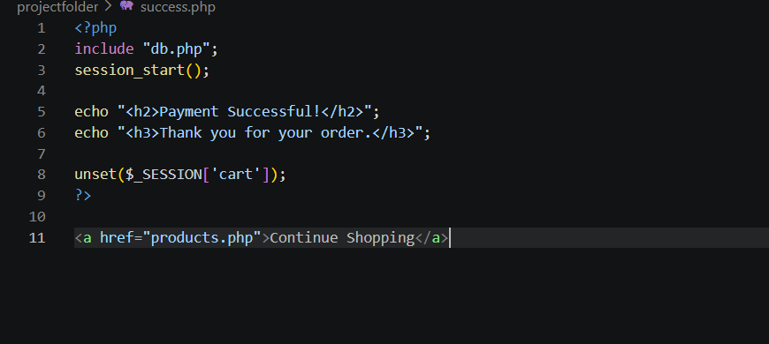
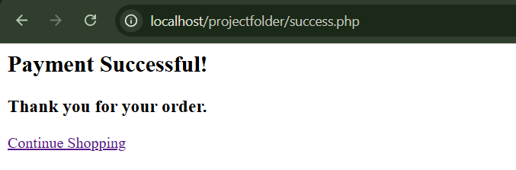

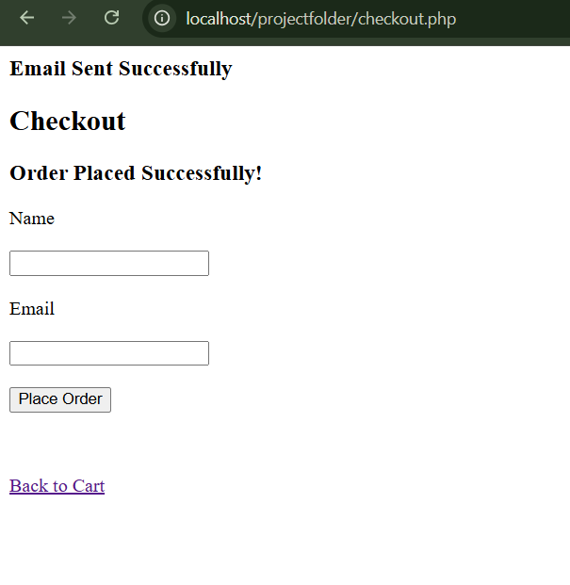
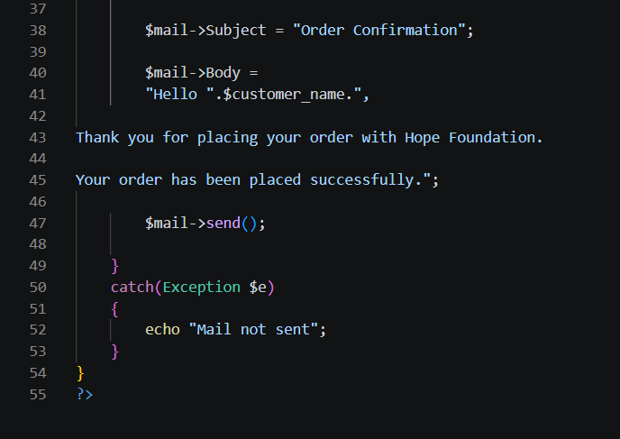
STEP 9: Modify checkout.php
